**WEEK 5 CHALLENGE**

1. **What is Relationship cardinality? Explain in details?**

**ANS:**

* The relationship cardinality means having unique or multiple instances per value for the joining field between two tables.
* Cardinality defined by the relationship and it refers to the relationship between two tables.

***Types of Cardinality :***

* **one-to-one relationships**:
* An uncommon type of relationship cardinality
* Both sides of the columns need to have unique values
* The most accurate name would be “zero- or-one”-to-“zero-or-one relationship
* The following figure shows one- to-one relationships

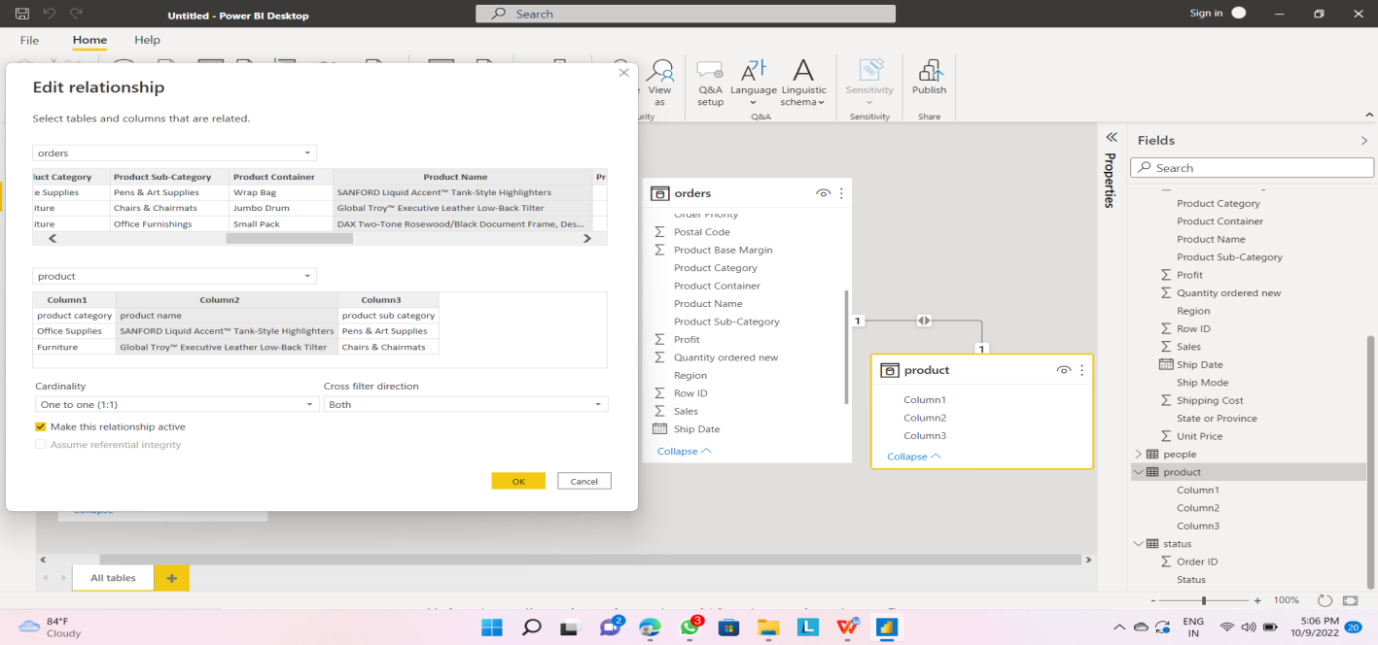

* **One-to-many relationships:**
* Most common type of relationship cardinality

1. One side column unique values
2. Other side values can contain duplicates
3. One-to-many & many-one relations are the same type of relationship

* The following figure shows one- to-many relationships

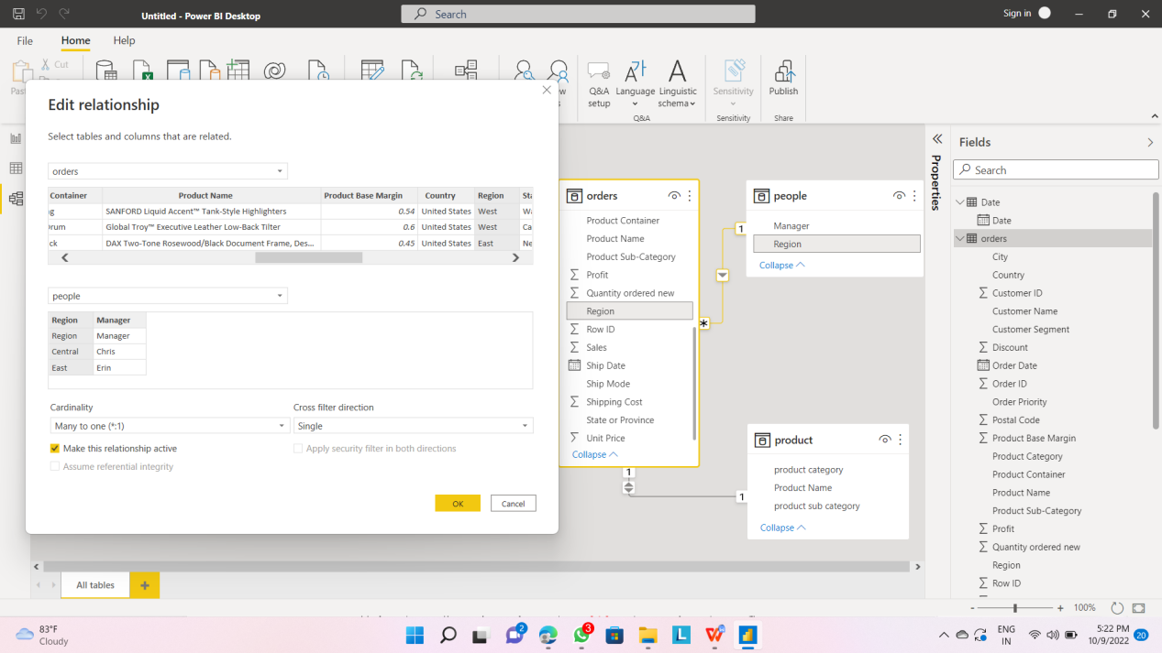

* **Many-to-many relationships:**
* On both sides of the relationship the columns can have duplicates
* The following figure shows one- to-many relationships

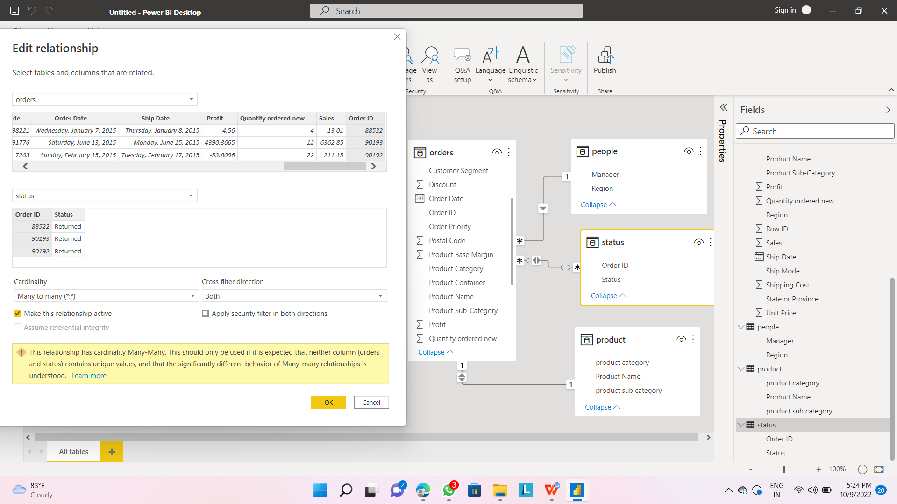

1. **What is filter flow? Explain with an example of filter flow?**

**ANS:**

***Filter flow:***

* Data filter will be flown from lookup table to Data table
* The filter context will be passed to all related data tables
* Filter cannot be applied against the direction.

***Example***

* Open the power bi desktop and load the data.
* Then go to power bi desktop views & click on report view.
* The following figure shows the report view icon.

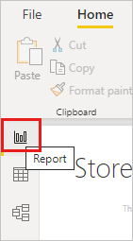

* Drag the data on to the data pane .
* After that filter the data using filter which is in “visualizations”.
* **The final output as shown in the below figure.**

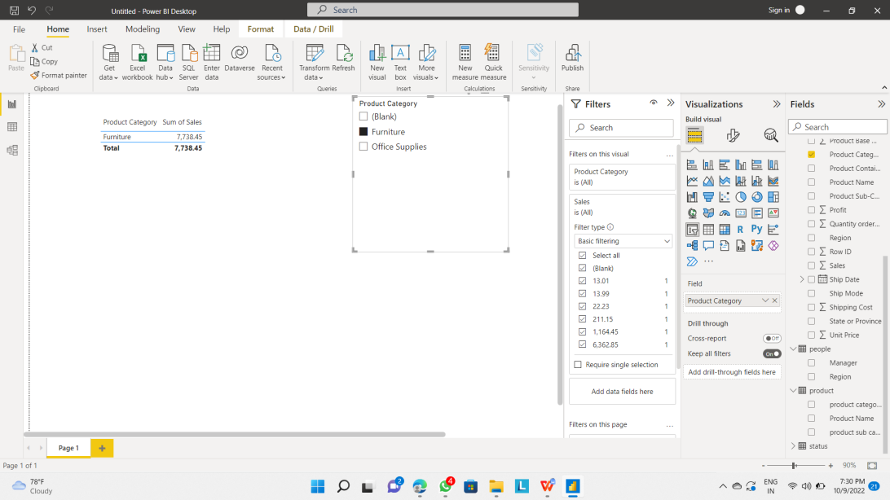

1. **Explain Many to Many Relationships with an example?**

**ANS:**

For example, two tables might have had a column labeled Country. The values of Country weren't unique in either table, though. To join such tables, you had to create a workaround. One workaround might be to introduce extra tables with the needed unique values. With relationships with a many-to-many cardinality, you can join such tables directly, if you use a relationship with a cardinality of many-to-many.

***Example:***

The following figure is the example for many-to-many relationships

